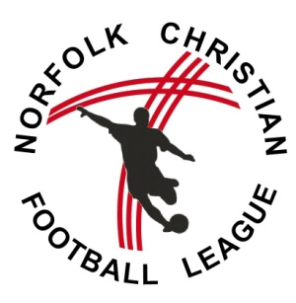
NCFL TEAM Affiliation Form: 2019/20 Season
FORM 2

A SEPARATE FORM NEEDS TO BE COMPLETED FOR EACH TEAM

We hereby seek affiliation to the Norfolk Christian Football League. We agree to abide by the rules and constitution of the League – in particular the Biblical Principles and Christian Ethics – and the decisions of the Management Committee.
PLEASE COMPLETE THE FORM CLEARLY AND IN BLOCK CAPITALS
Team Details: | 2019/20 details
Name of Club

Name of Team

Age division:
Team Colours:
(home and away)
Home Pitch: (including postcode)
Kick Off Time:

Dates unavailable
for fixtures
(e.g. school holidays)
Contact Details | Team Manager 2019/20
Name:
Address:
Landline Tel:
Mobile:
Email:
Church connection?
Please provide details of your church involvement
Team Manager Signature:
Club Secretary Signature:

- The final deadline for NCFL affiliation is Saturday 29th June 2019
- One form should be submitted for each team entered into the league
- Each form must include the signature of the Team Manager and the Club Secretary

By signing this form you are agreeing to the following communications. Please cross through if you do not agree.
- Receiving emails from the league - Receiving news emails from Network Norwich, website partner.
- Your contact details shared with other managers via the league contact list

